***Working with this manuscript:::***

The methods/analysis/results section and supplements of the paper will be written in Rmarkdown which allows the publishing of a fully reproducible manuscript (data and analysis code). In order to write the intro and discussion together in google docs in a way that can be quickly merged with the manuscript, here are some things to consider while writing:

* ***General****:*
  + note that formatting like bold or italics will not be preserved in the markdown manuscript unless its marked with the respective syntax:
    - one * for italics: *example* → *example*
    - two times * for bold print: **example** → **example**
* ***Headlines****:*
  + All headlines are marked with # (# heading)
  + smaller subheadings are created by adding # (## subheading level 2; ### subheading level 3)
* ***Citations***
  + if you are in a hurry, just past the DOI of the respective paper in brackets. I’ll sort it out later.
  + If you want to be a real sweetheart and add a full citation:
    - go to googlescholar and search the paper
    - click on the citation icon and then select bibtex
    - copy the entire bibtex entry into the googledoc named “manuscript_bibtex”. it's in the same google-folder as this document
    - copy the citation ID from the bibtex-code (that would be the entry after the first curly bracket and before the first comma. Its usually firstauthor+year+firstwordtitle (e.g. tomasello2010origins)
    - add the citation in text by using the following syntax: [@paperID]
      * e.g....as discussed in previous work [@tomasello2010origins]

**Thanks for your patience!**

**## Present investigation**

The aim was to investigate whether HR measures assessed by a Fitbit Charge 4 are a suitable and effective method to **(1)** map teachers course of arousal over the course of a five phase lab study, including a micro teaching unit,  and **(2)**  examine whether HR measures can be predicted by teachers’ teaching experience and self-reported data on cognitive appraisal during the micro teaching unit.

Within the time frame of approximately two hours, we investigated five intervals with a duration of 10-minutes each: In the (1) pre-teaching phase, the participants were prepared for the following micro teaching unit and familiarized with the setting. During the (2) teaching phase, the participants taught a 15-minute self-prepared lesson to a "class" of three actors that simulated nine classroom events. In the (3) post-teaching phase, the participants answered questionnaires, followed by the (4) interview phase, in which they watched the video of their 15-minute lesson. In the (5) end phase, the participant answered another questionnaire.

According to previous findings that fitness trackers can be used as a low-cost, non-invasive method of measuring HR [hajj2022wrist; @fuller2020reliability] and that different HRs of teachers can be measured in different teaching phases [@donker2020associations; @junker2021potential], we formulate the hypotheses as follows:

**Hypothesis 1**. In the first step, we exploratively looked at the HR trend throughout the entire study. We expected a similar course for the comparison of standardized versus non-standardized HR values, with both courses starting with a slope, then showing a peak, followed by a sharp decline (**Hypothesis 1a**). In the second step, we looked at the four phases separately and presumed the highest mean HR in the (2) teaching phase and lower mean values in all other phases (**Hypothesis 1b**). Moreover, we expected an increase in HR in the (1) pre-teaching phase as the first phase and a decrease in the following phases (**Hypothesis 1c**).

**Hypothesis 2**. We examined the effects of teaching experience and cognitive appraisal as self-reported data during the micro teaching unit on teachers’ HR responses. With respect to teaching experience, we expected a lower HR in teachers with more teaching experience (**Hypothesis 2a**). Concerning the cognitive appraisal, we expected higher HR values for teachers who felt more disrupted (**Hypotheses 2b**). In contrast, individuals with high confidence in dealing with disruptions would have a lower mean HR in the four phases (**Hypothesis 2c**). When considering the three predictors in concert, we expected teaching experience and self-reported data to remain substantial predictors (**Hypothesis 2d**).

**# Method**

**## Participants**

The sample consisted of *N* = 81 pre- and in-service teachers. The participants were recruited via personal contact, email lists and flyers. From the originally assessed data of 84 participants, three participants were excluded from the analyses due to insufficient data quality, yielding the analysis sample of 81.

The participants (*n* = 52 women, *n* = 29 man) had a mean age of 31 years (*SD* = 10.90; range: 19-60) and an average teaching experience of 5.64 years (*SD* = 9.46; range: 0-37). A percentage of 14.81/70.37/9.88% of the participants stemmed from school forms of primary/secondary/special educational needs schools.

**## Procedure and setting**

The whole study had a duration of approximately two hours (for detailed information about the procedure, see Fig. ##). Within this timeframe, teachers taught a 15-minute self-prepared lesson to an audience of three actors who simulated typical classroom events (see Fig. ##).

Ein Bild, das Mobiliar, Stuhl, Kleidung, Schuhwerk enthält.

**Fig. 1.**Setting of the 15-minute micro teaching unit. *Note.* The setting included three actors as the class (left) and a teacher (right).

Subsequently, the participants filled out questionnaires and were interviewed about the previously taught lesson while watching selected sequences of the lesson on video (see Fig. 2). Over the course of this two-hours study, we selected five 10-minute intervals of theoretical interest: (1) pre-teaching phase, (2) teaching phase, (3) post-teaching phase, (4) interview phase and (5) end phase (see Fig. ##).

Ein Bild, das Mobiliar, Zeichnung, Entwurf, Tisch enthält.
**Fig. 2.** Setting of the interview. *Note.* The experimenter and participant rewatched the previously taught lesson on video.

After the experimenter welcomed the participants and put on the watch, the procedure of the study was briefly explained and written consent to voluntarily participate in the study was requested. Next, the participants were asked to prepare the necessary materials for the lesson (connecting the laptop to the beamer, preparing worksheets, etc.). Once the preparation was completed, a warm-up phase took place to familiarize the participants with the laboratory setting and the actors. This warm-up phase consisted of two parts: In the first part, the participants and the three actors playfully learned each other's names. The second part involved getting into conversation with each other by asking short questions guided by interests (e.g., about hobbies or favorite places). The preparation time before the lesson started lasted 10-15 minutes on average. Most participants spent this time standing and slightly moving during the warm-up game.

After the preparation and warm-up, the participants started the 15-minute micro teaching unit teaching a self-prepared lesson to three trained actors. During the lesson, the actors simulated nine typical classroom events of three different categories (see Table ## in Appendix ## for all events). To avoid sequency effects of the order of the events and the performing actors we used a fully balanced Latin square design. The actors received instructions on a screen, primarily visible only to them, every one and a half minute on what event to perform. However, the events did not start until two and a half minutes after the participants started teaching to ensure a short period of familiarization with the setting. The events should be executed for 30 seconds, unless there was a reaction from the participants. The actors were trained to stop the disruptive behavior as soon as the teachers intervened. To ensure that the participants did not exceed the time, the time management in the micro-teaching unit was regulated by the experimenter by showing timecards of the remaining time to the participants. The lesson lasted about 20 minutes on average. The participants’ position was mostly standing and moving during the lesson.

After the micro teaching unit, the participants as well as the actors were given a short questionnaire on demographics and teaching quality of the lesson. The completion of the questionnaire took approximately 10 minutes. Most participants completed the questionnaire in a seated position.

Subsequently, the participants watched the video of the lesson. The experimenter stopped the video each time one of the nine events happened and asked several questions. First, participants were asked to describe the disruption and then to evaluate to the disruptiveness of the event on a 11-point rating scale (= disruption factor). In a next step, participants were asked to explain their chosen score between 0 and 10 for the disruption factor. Subsequently, the subjects were asked to first describe their reaction to an event and then to justify their reaction. The experimenter then asked the participants first to evaluate the confidence they had in dealing with the disruption on a 11-point rating scale (= confidence factor) and secondly, to again to explain the chosen value for the confidence factor. The interview lasted 45-60 minutes on average. The participants’ position in this phase was seated during the interview.

After the interview, the participants answered a second questionnaire mainly seated and in a calm position. The completion of the questionnaire lasted approximately 10-15 minutes.

All study procedures were carried out in accordance with the ethical standards of the University’s Institutional Review Board and the authors received a positive vote on the study procedures from the Ethics Committee. All participants were informed in detail about the aim and intention of the study prior to testing. Participation was voluntary and only took place after written consent had been given.

**## Variables**

**### Teaching Experience**

The participants’ teaching experience was assessed as a part of sociodemographic data via an online questionnaire using SoSci Survey (Version 3.1.06; Leiner, 2019) and made available on www.soscisurvey.de. Participants were asked to enter their work experience excluding the traineeship year as a numerical value in an open input field.

**### Heart Rate**

We used a Fitbit Charge 4 to measure the teachers’ HR. In line with the manufacturer's instructions, the device was attached a finger’s width above the participants’ wrist bone [@fitbitnd]. To determine the HR, the Fitbit flashes green LEDs many times per second and uses light-sensitive photodiodes to measure the volume changes in the capillaries and then calculates how many times the heart beats per minute (bpm).

**### Cognitive appraisal**

Cognitive appraisal was assessed for each of the nine disruptions by two items with a 11-point rating scale, ranging from 0 (not at all) to 10 (extremely). For each scale, the mean was calculated over the nine items. One item referred to the disruptiveness of the event (How disruptive was this event for you?); the other item referred to the participants’ confidence in dealing with the event (How confident did you feel, dealing with this event?).

**## Data analysis**

We conducted all analysis with R [@RStudio2020]. For analyzing the HR data, we focused on five 10-minute intervals of theoretical interest:

The first interval, the (1) pre-teaching phase, was calculated from the moment the Fitbit watch was put on, which happened immediately after the participants were welcomed. The second interval, the (2) teaching phase, began with the experimenter noting the time and step count of the fitness tracker. To ensure that the analysis interval starts with the teaching activity, another two minutes were added to the noted time. The (3) post-teaching phase began immediately after the end of the teaching lesson. The (4) interview phase was 10 minutes in the middle of the interview where we calculated the difference from the end of the lesson and from the time when the participants took off the watch. This duration was divided in two to get to the middle of the interval. Then, 5 minutes were subtracted to get to the start of the 10-minute interval. The (5) end phase were the last 10min before the participants took off the watch.

We selected 10-minute intervals for multiple reasons: First, 10 minutes was the minimum duration of all five phases, so we ensured the comparability of the phases for all participants. Second, @lu2008can confirmed in their study that 10-minute intervals are a useful duration for analyzing photoplethysmography (PPG) data. Third, previous studies revealed that the first minutes of the lesson start are essential regarding teacher-student interaction [@donker2018quantitative; @claessens2017positive].

To account for individual differences in the baseline HR, unstandardized values in bpm were z-standardized. Thus, resulting values can be interpreted as differences from the overall HR mean in standard deviations.

Regarding the course of HR during the study, we first displayed the anticipated trend for the mean HR in beats per minute and the standardized HR over the course of the entire study.

To test **Hypothesis 1a**, we calculated paired *t*-tests and the effect size *d* [@cohen1988new] to test for differences in standardized HR using HR means between the (2) teaching phase and the other four phases.

For testing **Hypothesis 1b**, we conducted a linear estimation of the increase and decrease in HR over time. To this end, we used fixed intercept-fixed slope regression [@gelman2006data] to estimate linear slopes and intercepts for all individuals.[1]

Regarding

In the first step, we investigated the influence of teaching experience on the participants’ standardized mean HR for the (1) pre-teaching phase, the (2) teaching phase, the (3) post-teaching phase, the (4) interview phase, and the (5) end phase by linear regression models (Hypothesis 2a). In the next step, we augmented the models by the self-reported data on the disruptiveness of the events (**Hypothesis 2b**) and on the participants’ confidence in dealing with the events (Hypothesis 2c), while controlling for the shared variance with teaching experience. In the last step, we conducted multiple regression models that considered the effects of the three predictors on the standardized mean HR in concert (Hypothesis 2d).

**# Results**

**## Heart rate course**

Concerning our first hypothesis, we displayed the trend of the course of HR during the entire study. Teachers’ unstandardized mean HR over the entire course of the study was *M* = 90.09 bpm and *SD* = 15.76 bpm (range 51 - 164 bpm). The standardized mean HR over the entire course of the study was *M* = -0.04 and *SD* = 0.99 (range -4.03 - 4.56).Means, standard deviations, and the range of teachers’ unstandardized and standardized HR in the different phases are shown in Table XX.

Table XX M*,* SD *and range of teachers’ HR for the individual phases (unstandardized in bpm/z-standardized)*

|  |  |  |  |  |
| --- | --- | --- | --- | --- |
| Phase | *M* | *SD* | Min | Max |
| (1) Pre-teaching phase | 96.28/0.48 | 14.11/0.88 | 56/-3.56 | 139/3.24 |
| (2) Teaching phase | 100.80/0.85 | 16.23/0.77 | 63/-2.18 | 164/4.37 |
| (3) Post-teaching phase | 93.61/0.27 | 14.01/0.76 | 60/-2.17 | 150/3.06 |
| (4) Interview phase | 82.32/-0.72 | 11.85/0.74 | 51/-2.51 | 132/4.39 |
| (5) End phase | 77.95/-1.07 | 11.14/0.57 | 50/-2.68 | 120/2.96 |

Based on the HR values shown in Table XX, the participants started with a comparatively high mean HR already in the (1) pre-teaching phase. The numerically highest mean HR measure was in the (2) teaching phase and the lowest mean HR measure was in the (5) end phase. A decrease in HR for the following phases can be observed after the teaching phase.

Fig. XX a. shows the unstandardized mean HR in bpm and Fig. XX b. shows the standardized mean HR over the entire course of the study of approximately two hours.

Figure XX *Overall Course of the HR in Beats per Minute and Standardized*

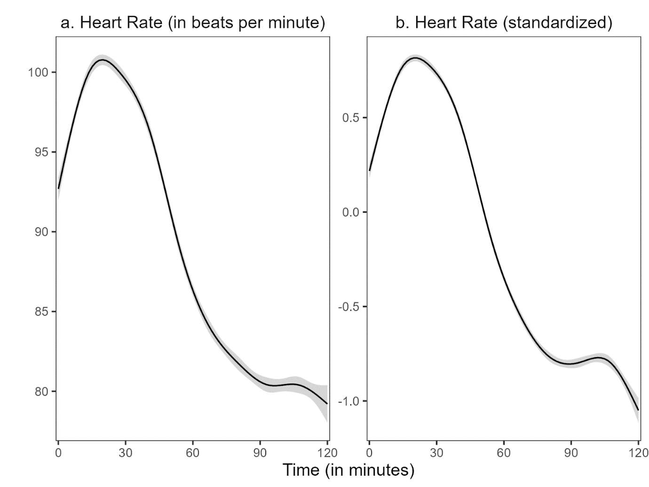

*Note:* The shadow around the line represents the 99% confidence interval. We used the ggplot2 package (v3.3.3; Wickham, 2016) to calculate the moving average of the course.

Fig. XX a. and Fig. XX b. clearly showed that in reference to the course of the HR, the HR increased in the (2) teaching phase and decreased in the following phases. Comparing both courses, it is apparent that the course of the non-standardized mean HR is similar to the course of the standardized mean HR.

Referring to **Hypothesis 1a**, the standardized mean HR in the (2) teaching phase compared to the (1) pre-teaching phase was significantly higher, *t*(80) = 4.99, *p* < .05, *d* = 0.82 (large effect). When comparing the standardized mean HR between the (2) teaching phase and the (3) post-teaching phase, the results revealed a statistically significant difference between these two phases, *t*(80) = 7.59, *p* < .05, *d* = 1.34 (large effect) as well as the comparison between (2) teaching and (4) interview phase, *t*(80) = 18.29, *p* < .05, *d* = 3.37 (large effect). The standardized mean HR in the (2) teaching phase compared to the (5) end phase was significantly higher as well, t(80) = 27.94, *p* < .05, *d* = 4.68 (large effect).

Figure XX*1% Confidence Interval in each phase*

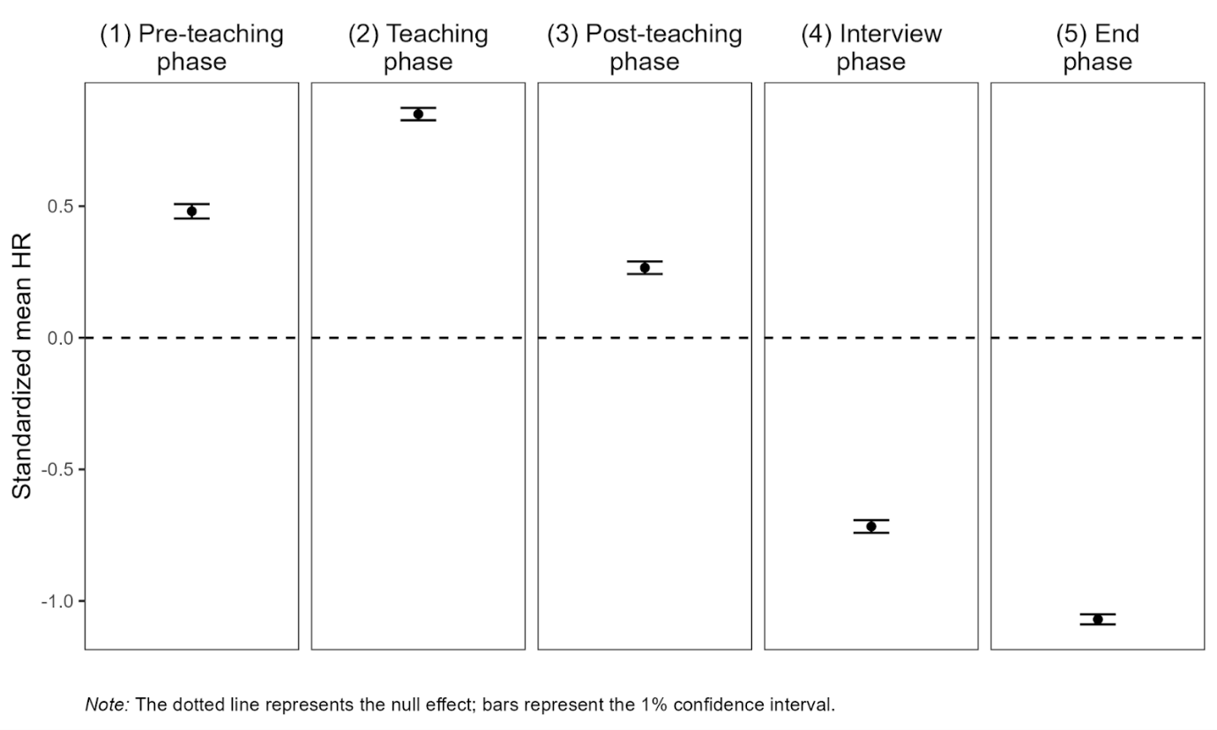

Fig. XX shows the mean standardized HR for the five different phases. The trend, which showed up in the entire course of the HR, can be found in the figure as well. We can see the highest mean HR in the (2) teaching phase and lower mean values in all other phases.

Referring to **Hypothesis 1b**, we estimated linear slopes for all individuals to investigate the increase and decrease in HR over time. Additionally, we calculated the intercepts.

Table XX n, M, SD *of individual intercepts/slopes*

|  |  |  |  |
| --- | --- | --- | --- |
| Phase | n1 | *M* | SD |
| (1) Pre-teaching phase | 6896 | 0.052/0.085* | 0.820/0.133 |
| (2) Teaching phase | 7150 | 1.025*/-0.039* | 0.690/0.108 |
| (3) Post-teaching phase | 6664 | 0.549*/-0.060* | 0.547/0.101 |
| (4) Interview phase | 6287 | -0.617*/-0.022 | 0.614/0.070 |
| (5) End phase | 5990 | -1.004*/-0.012 | 0.500/0.074 |
| *Note.* * *p* < .05, 1All measurement time points for all participants per phase included in the calculations. | | | |

Table XX shows that mean intercepts differed significantly from zero for all phases except the (1) pre-teaching phase. On average, the mean slopes were negative for all phases but the (1) pre-teaching phase, which means that the participants’ mean HR increased over the course of the (1) pre-teaching phase. By contrast, the participants’ mean HR decreased in the later course of the study. The mean slope was significantly different from zero for the first three phases.

Fig. XX shows the linear estimation for standardized mean HR for the five different phases. The trend of the entire course of HR can also be represented in this Fig. XX. We see a strong slope in the (1) pre-teaching phase and a decrease in the following phases. In the (4) interview and (5) end phase there is hardly any slope left.

Fig. XX *Linear estimation for standardized mean HR in each phase*

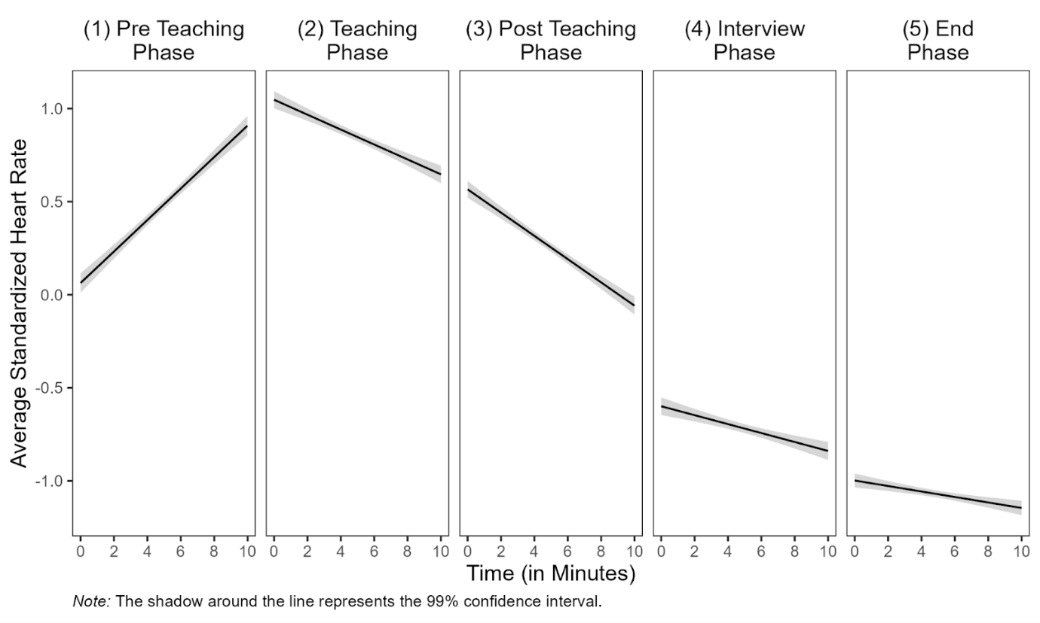

**## Prediction of mean HR with teaching experience and self-report data:**

Correlations between the standardized mean HR and the predictor variables for the different phases are shown in Table XX - XX.

Table XX *Partial correlations between standardized mean HR, teaching experience, disruption factor, confidence factor and gender for (1) pre-teaching phase*

|  |  |  |  |  |
| --- | --- | --- | --- | --- |
| Variable | 2 | 3 | 4 | 5 |
| 1 HR | − .18 | − .10 | − .03 | .18 |
| 2 TE |  | **− .26\*** | **.34\*** | .10 |
| 3 DF |  |  | **− .24\*** | .10 |
| 4 CF |  |  |  | − .07 |
| 5 G |  |  |  | − |
| *Note.* HR = standardized mean heart rate, TE = teaching experience, DF = disruption factor, CF = confidence factor, G = gender. * *p* < .05, additionally highlighted in bold. | | | | |

Table XX shows that correlations between the standardized mean HR and predictor variables in the (1) pre-teaching phase were only significant between teaching experience and the self-report data (disruption factor: *r* = − .26, confidence factor: *r* = .34). Moreover, the disruption and confidence factor correlated significantly as well (*r* = − .24).

Table XX *Partial correlations between standardized mean HR, teaching experience, disruption factor, confidence factor and gender for (2) teaching phase*

|  |  |  |  |  |
| --- | --- | --- | --- | --- |
| Variable | 2 | 3 | 4 | 5 |
| 1 HR | 0.03 | − .19 | − .02 | .15 |
| 2 TE |  | **− .23\*** | **.36\*** | .07 |
| 3 DF |  |  | **− .25\*** | .11 |
| 4 CF |  |  |  | − .08 |
| 5 G |  |  |  | − |
| *Note.* HR = standardized mean heart rate, TE = teaching experience, DF = disruption factor, CF = confidence factor, G = gender. * *p* < .05, additionally highlighted in bold. | | | | |

In the (2) teaching phase, the teaching experience correlated significantly with the disruption (*r* = − .23) and the confidence (*r* = − .36) factor and the self-report data with each other (*r* = − .23).

Table XX *Partial correlations between standardized mean HR, teaching experience, disruption factor, confidence factor and gender for (3) post-teaching phase*

|  |  |  |  |  |
| --- | --- | --- | --- | --- |
| Variable | 2 | 3 | 4 | 5 |
| 1 HR | .00 | **.24\*** | .11 | − .10 |
| 2 TE |  | **− .23\*** | **.35\*** | .08 |
| 3 DF |  |  | **− .27\*** | .10 |
| 4 CF |  |  |  | − .07 |
| 5 G |  |  |  | − |
| *Note.* HR = standardized mean heart rate, TE = teaching experience, DF = disruption factor, CF = confidence factor, G = gender. * *p* < .05, additionally highlighted in bold. | | | | |

Table XX shows that in the (3) post-teaching phase, the dependent variable correlated significantly with the disruption factor (*r* = .24). Additionally, the teaching experience again correlated significantly with the disruption (*r* = − .23) and the confidence (*r* = .35) factor and both factors with each other (*r* = − .27).

Table XX *Partial correlations between standardized mean HR, teaching experience, disruption factor, confidence factor and gender for (4) interview phase*

|  |  |  |  |  |
| --- | --- | --- | --- | --- |
| Variable | 2 | 3 | 4 | 5 |
| 1 HR | .21 | − .05 | − .04 | − .07 |
| 2 TE |  | **− .22\*** | **.36\*** | .09 |
| 3 DF |  |  | **− .25\*** | .08 |
| 4 CF |  |  |  | − .08 |
| 5 G |  |  |  | − |
| *Note.* HR = standardized mean heart rate, TE = teaching experience, DF = disruption factor, CF = confidence factor, G = gender. * *p* < .05, additionally highlighted in bold. | | | | |

Table XX shows that in the (4) interview phase, the teaching experience again correlated significantly with the disruption (*r* = − .22) and the confidence (*r* = .36) factor and both factors with each other as well (*r* = − .25).

Table XX *Partial correlations between standardized mean HR, teaching experience, disruption factor, confidence factor and gender for (5) end phase*

|  |  |  |  |  |
| --- | --- | --- | --- | --- |
| Variable | 2 | 3 | 4 | 5 |
| 1 HR | .10 | .05 | − .11 | − .18 |
| 2 TE |  | **− .25\*** | **.36\*** | .10 |
| 3 DF |  |  | **− .24\*** | .09 |
| 4 CF |  |  |  | − .10 |
| 5 G |  |  |  | − |
| *Note.* HR = standardized mean heart rate, TE = teaching experience, DF = disruption factor, CF = confidence factor, G = gender. * *p* < .05, additionally highlighted in bold. | | | | |

In the (5) end phase, the teaching experience again correlated significantly with disruption (*r* = − .25) and the confidence (*r* = .36) factor and both factors with each other as well (*r* = − .24).

The predictions of the participants’ standardized mean HR for the (2) teaching, the (3) post-teaching, the (4) interview and the (5) end phase with teaching experience are shown in Table XX - XX.

Table XX shows the prediction of HR with teaching experience and self-report data for the (2) teaching phase.

Table XX *Multiple linear regression for (2) teaching phase*.

|  | *Dependent Variable: Standardized mean HR* | | | | | | | |
| --- | --- | --- | --- | --- | --- | --- | --- | --- |
|  | *(1)* | | *(2)* | | (3) | | (4) | |
|  | Est. | *p* | Est. | *p* | Est. | *p* | Est. | *p* |
| Teaching Experience | 0.005 (0.005) | .34 | 0.002 (0.005) | .73 | 0.005 (0.006) | .42 | 0.003  (0.006) | .67 |
| Disruption Factor |  |  | -0.062 (0.041) | .13 |  |  | -0.065  (0.042) | .13 |
| Confidence Factor |  |  |  |  | 0.004 (0.046) | .92 | -0.014 (0.047) | .76 |
| Constant | **0.813* (0.057)** | <.01 | **1.150* (0.227)** | <.01 | **0.778* (0.349)** | .03 | **1.274* (0.471)** | .01 |
| *Note*. * *p* < .05, additionally highlighted in bold, Standard error in parentheses. | | | | | | | | |

The multiple linear regression revealed no significant effects for the (2) teaching phase (see Table XX).

Table XX shows the prediction of HR with teaching experience and self-report data for the (3) post-teaching phase.

Table XX *Multiple linear regression for (3) post-teaching phase*.

|  |  |  | *Dependent Variable: Standardized mean HR* | | | | | | | |
| --- | --- | --- | --- | --- | --- | --- | --- | --- | --- | --- |
|  |  |  | *(1)* | | *(2)* | | (3) | | (4) | |
|  |  |  | Est. | *p* | Est. | *p* | Est. | *p* | Est. | *p* |
|  |  | Teaching Experience | 0.002 (0.005) | .70 | 0.002 (0.005) | .76 | -0.003 (0.006) | .55 | -0.001  (0.006) | .22 |
|  |  | Disruption Factor |  |  | 0.073 (0.040) | .07 |  |  | **0.084\***  **(0.041)** | .04 |
|  |  | Confidence Factor |  |  |  |  | 0.027 (0.045) | .55 | 0.051 (0.046) | .27 |
|  |  | Constant | **0.272* (0.005)** | <.01 | -0.122 (0.222) | .59 | 0.069 (0.343) | .84 | -0.570 (0.457) | .22 |
|  |  | *Note*. * *p* < .05, additionally highlighted in bold, Standard error in parentheses. | | | | | | | | |

The multiple linear regression shown in Table XX revealed a significant effect for the (3) post-teaching phase when predicting the HR with teaching experience and controlling for the disruption factor (*b* = 0.084, *p* < .05).

Table XX shows the prediction of HR with teaching experience and self-report data for the (4) interview phase.

Table XX *Multiple linear regression for (4) interview phase*.

|  | *Dependent Variable: Standardized mean HR* | | | | | | | |
| --- | --- | --- | --- | --- | --- | --- | --- | --- |
|  | *(1)* | | *(2)* | | (3) | | (4) | |
|  | Est. | *p* | Est. | *p* | Est. | *p* | Est. | *p* |
| Teaching Experience | **0.012* (0.006)** | .03 | 0.011 (0.006) | .06 | **0.013* (0.006)** | .04 | 0.012  (0.007) | .07 |
| Disruption Factor |  |  | -0.020 (0.044) | .60 |  |  | -0.024  (0.047) | .61 |
| Confidence Factor |  |  |  |  | -0.010 (0.050) | .85 | -0.016 (0.052) | .76 |
| Constant | **0.793* (0.062)** | <.01 | -0.684 (0.252) | <.01 | -0.721 (0.382) | .06 | -0.541 (0.522) | .30 |
| *Note*. * *p* < .05, additionally highlighted in bold, Standard error in parentheses. | | | | | | | | |

The multiple linear regression shown in Table XX revealed significant effects for the (4) teaching phase when predicting the HR only with teaching experience (*b* = 0.012, *p* < .05) and teaching experience when controlling for the confidence factor (*b* = 0.013, *p* < .05).

Table XX shows the prediction of HR with teaching experience and self-report data for the (5) end phase.

Table XX *Multiple linear regression for (5) end phase*.

|  | *Dependent Variable: Standardized mean HR* | | | | | | | |
| --- | --- | --- | --- | --- | --- | --- | --- | --- |
|  | *(1)* | | *(2)* | | (3) | | (4) | |
|  | Est. | *p* | Est. | *p* | Est. | *p* | Est. | *p* |
| Teaching Experience | 0.002 (0.004) | .67 | 0.003 (0.005) | .58 | 0.004 (0.005) | .46 | 0.004 (0.005) | .43 |
| Disruption Factor |  |  | 0.019 (0.035) | .60 |  |  | 0.011 (0.037) | .76 |
| Confidence Factor |  |  |  |  | -0.035 (0.039) | .38 | -0.032 (0.041) | .44 |
| Constant | **-1.075* (0.049)** | <.01 | **-1.176* (0.199)** | <.01 | -0.811 (0.300) |  | **-0.897* (0.411)** | .03 |
| *Note*. * *p* < .05, additionally highlighted in bold, Standard error in parentheses. | | | | | | | | |

The multiple linear regression revealed no significant effects for the (5) end phase (see Table XX).

Regarding **Hypothesis 2a**, the prediction of the participants’ mean HR for the (2) teaching, the (3) post-teaching, the (4) interview, and the (5) end phase with teaching experience revealed only for the fourth phase, the (4) interview phase, (Table XX, Model 1) a significant result (*b* = 0.012, *p* < .05). When controlling the teaching experience for shared variance with the self-reported data (**Hypothesis 2b**), the disruption factor was a significant predictor for the mean HR in the (3) post-teaching phase (*b* = 0.084, *p* < .05, see Table XX Model 4). When controlling for shared variance with the confidence factor (**Hypothesis 2b**) and considering the three predictors in concert and controlling for their common variance (**Hypothesis 2c**), the models revealed no significant effects.

1. Although this procedure does not account for nonmonotonic progressions in individual HR, a graphical evaluation reveals that the linear estimates fit well for most of the cases (see XX in the appendix).